Pruebas CRUD con Postman

1: GET http://localhost:8080/person
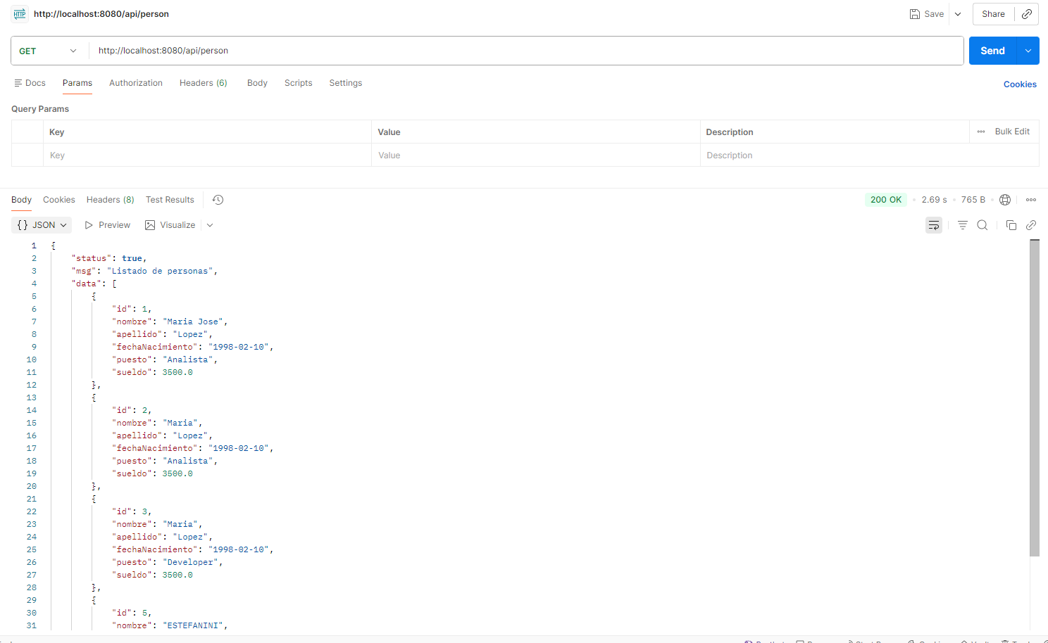

2: POST http://localhost:8080/person
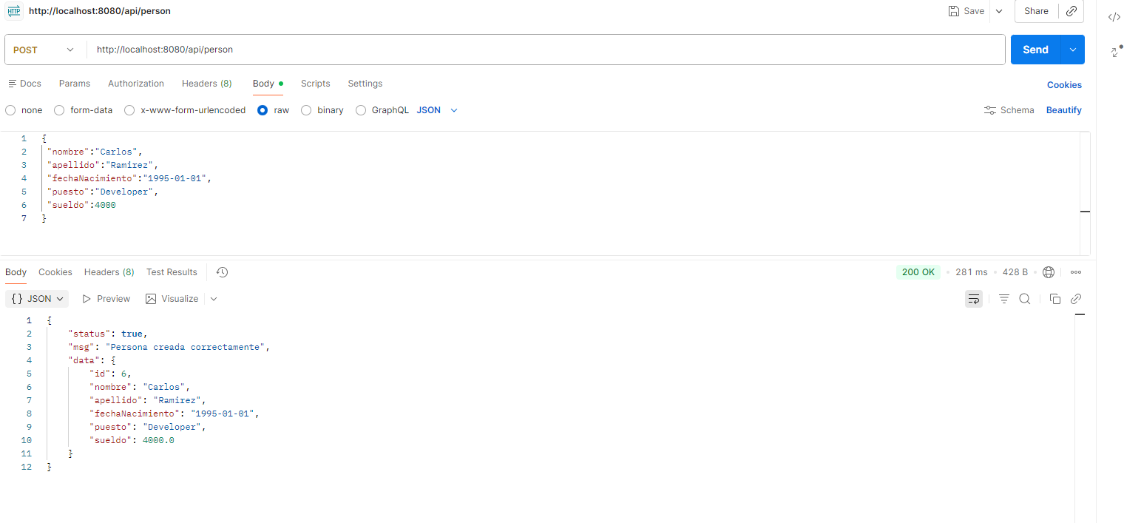
3: PUT http://localhost:8080/person/1
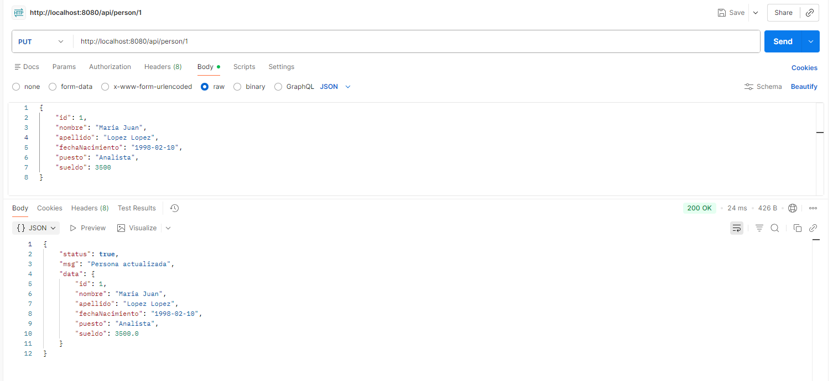

4: DELETE http://localhost:8080/person/1
